

Southeast University
Department of Computer Science and Engineering (CSE)
School of Sciences and Engineering
Semester: (Summer, Year: 2026)

LAB REPORT NO: 01
Course Title: Operating Systems Lab
Course Code: CSE362.2
Batch: 65

Lab Experiment Name: Implementing fundamental Linux command.

Student Details

Name |  | ID
1. | Md. Mahmud Hossain | 2023200000799

Submission Date : 13-07-26
Course Teacher’s Name : Md. Ismail

Lab Report Status
Marks: ………………………………… Signature:.....................
Comments:.............................................. Date:..............................

Command 1: help
Description: Display the list of all Linux commands.
Screenshot:
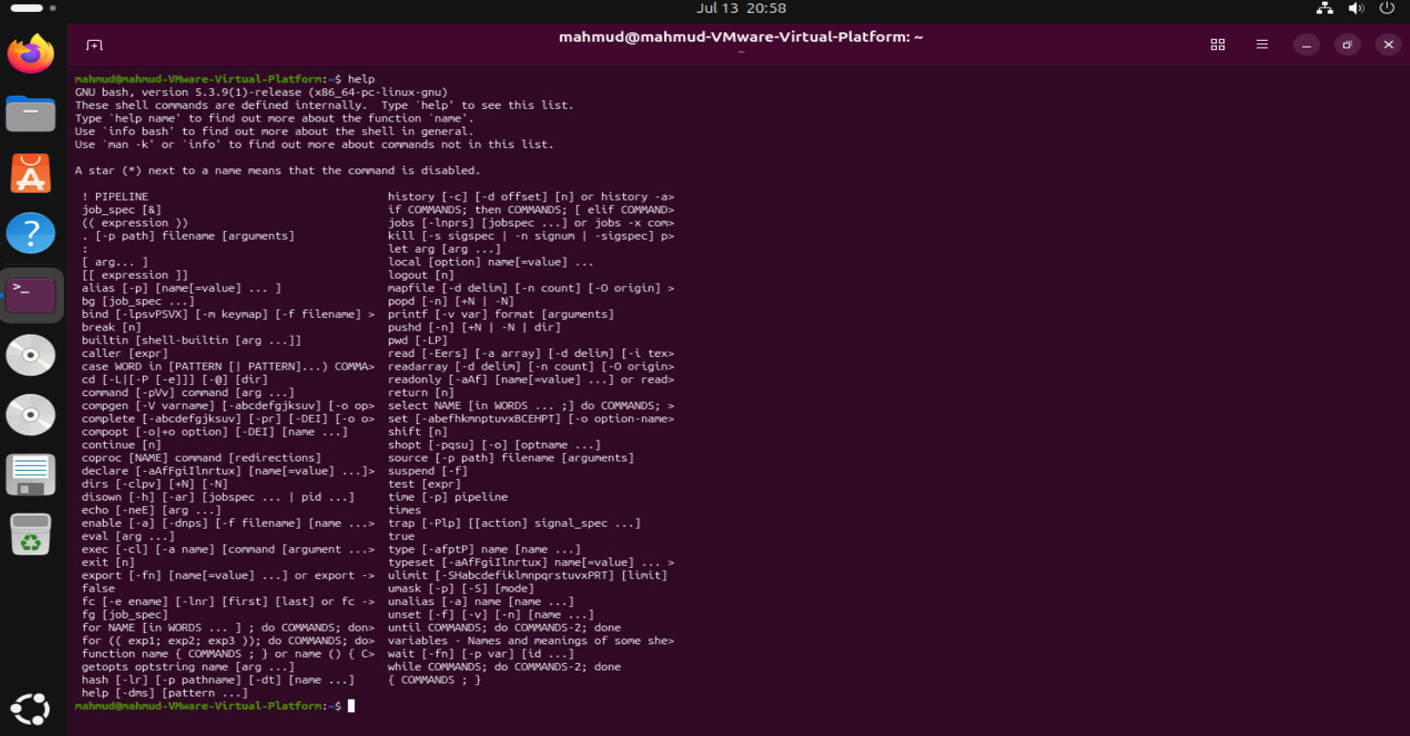

Command 2: help command_name
Description: Display detailed information about Linux command how it works.
Screenshot:
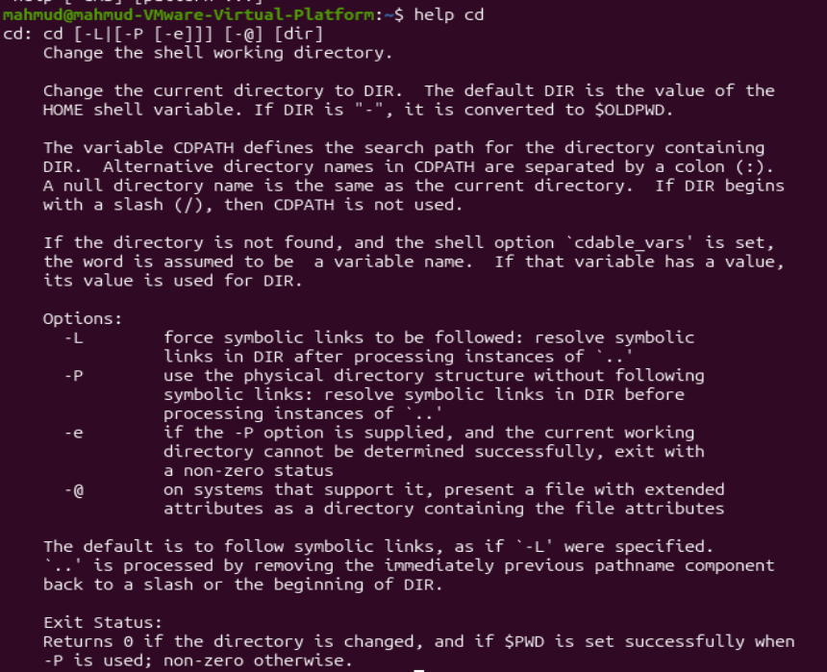

Command 3: pwd
Description: Display current directory
Screenshot:
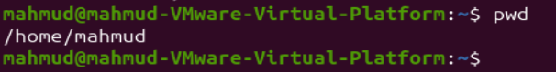

Command 4: mkdir folder_name
Description: Create a new folder
Screenshot:
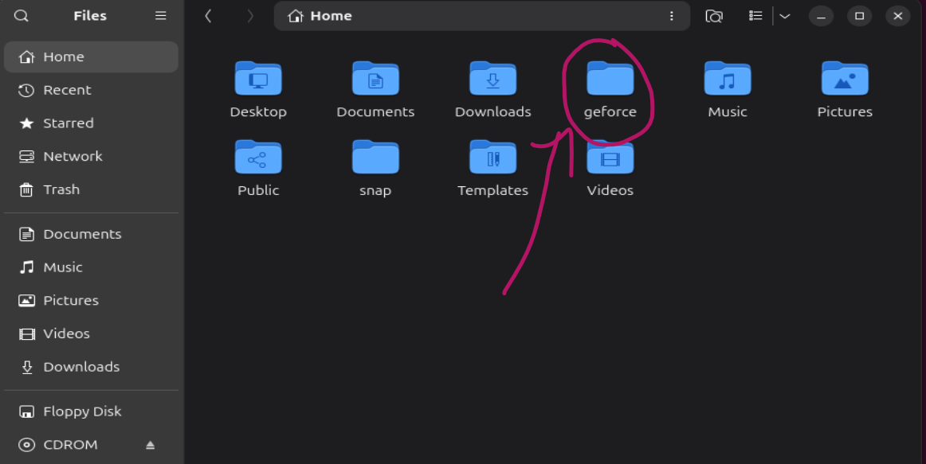

Command 5: touch file_name.file_extention
Description: Create a new file with particular format
Screenshot:
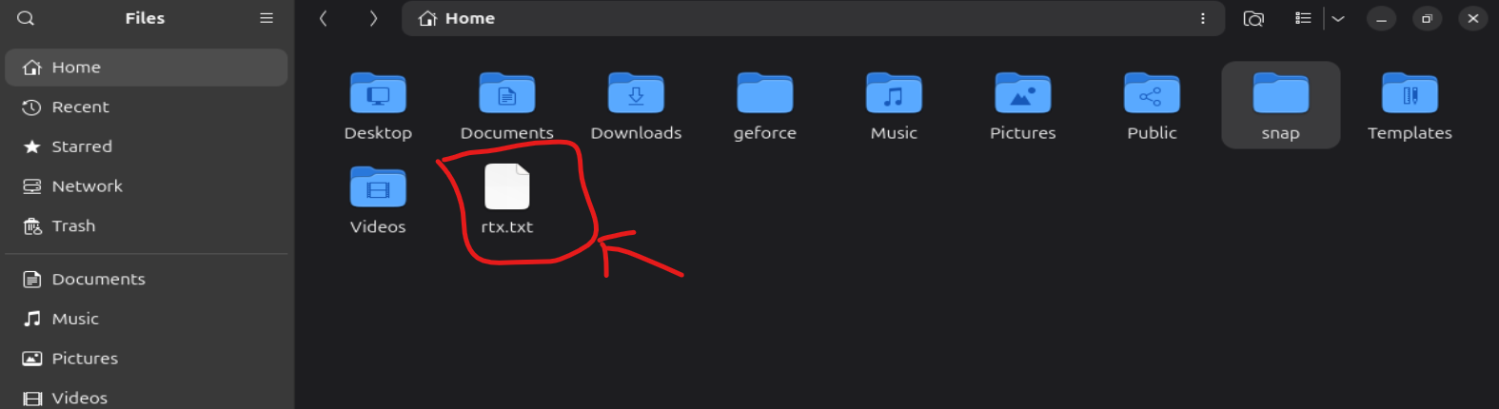

Command 6: cd address
Description: For change directory address
Screenshot:
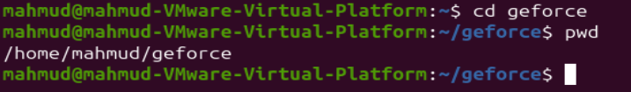

Command 7: rm file_name
Description: For remove file
Screenshot:
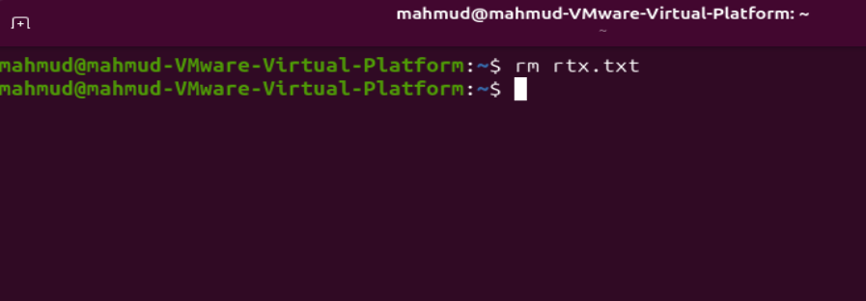

Command 8: mv file_previous_name file_updated_name
Description: For rename file
Screenshot:
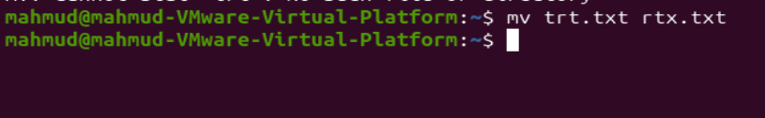
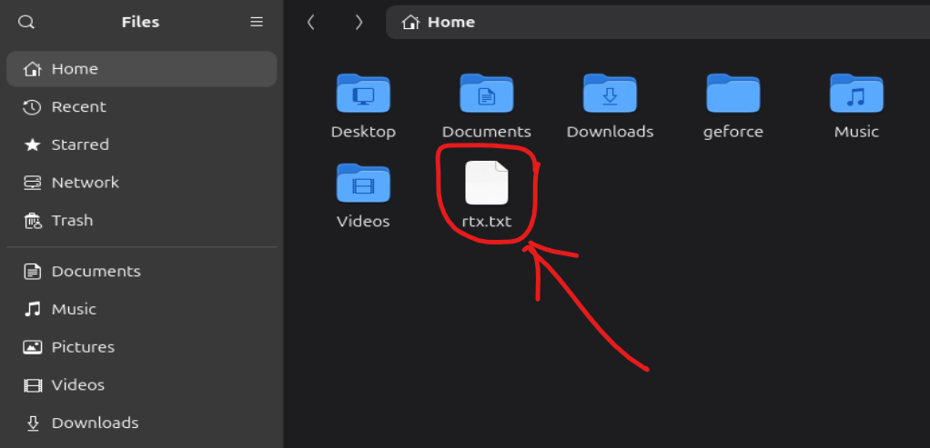

Command 9: zip zip_file_name file_name_1 file_name_2 .... file_name_n
Description: For zip multiple file in on folder
Screenshot:
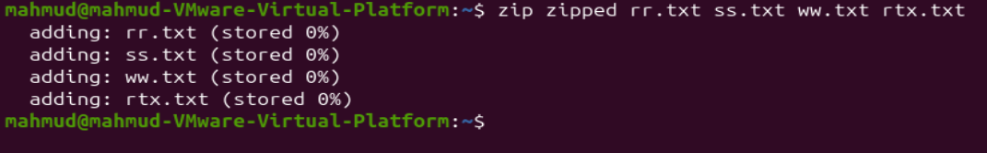
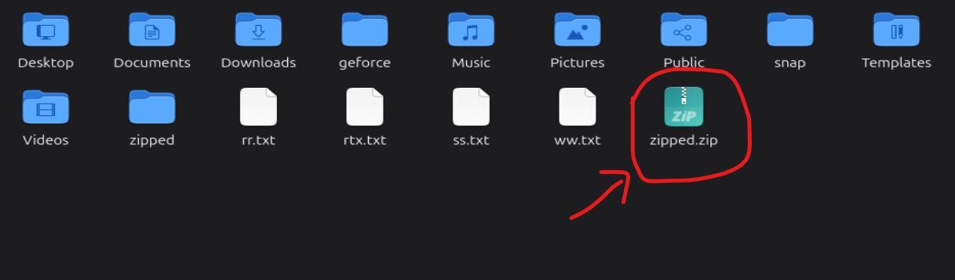
Command 10: unzip zip_file_name
Description: For unzip a zip file
Screenshot:
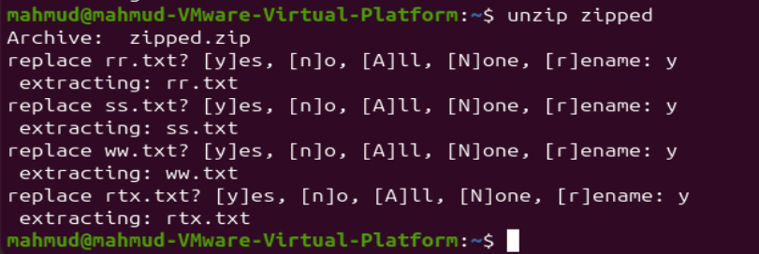

Command 11: cat file_name1 file_name_2 --> file-name_3
Description: For combining multiple file info into 1 file
Screenshot:

Command 12: head -n number_of_line file_name.ext
Description: to show first number_of_line
Screenshot:
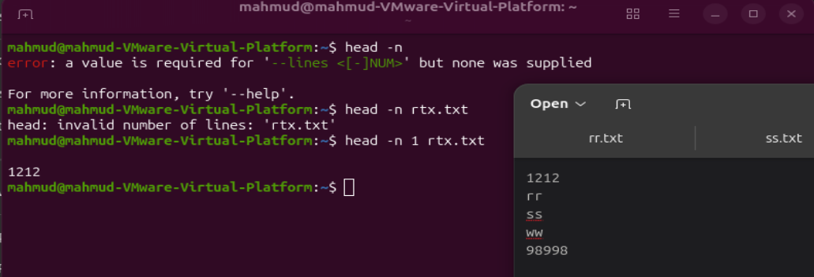

Command 13: tail -n number_of_line file_name.ext
Description: To show last number_of_line
Screenshot:
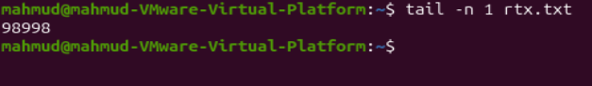

Command 14: grep keyword_name file_name.ext
Description: To find the specific keyword in a file
Screenshot:
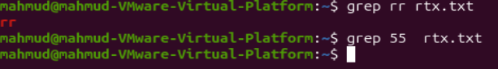

Command 15: diff file_name_1 file_name_2
Description: To find the difference between two fill. or find the similarity between two files
Screenshot:
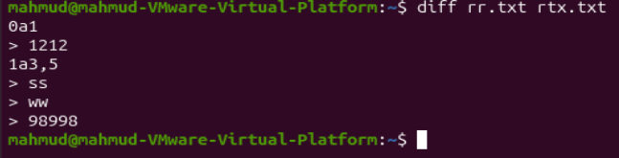

Command 16: wget url
Description: To download a file form a specific url address.
Screenshot:
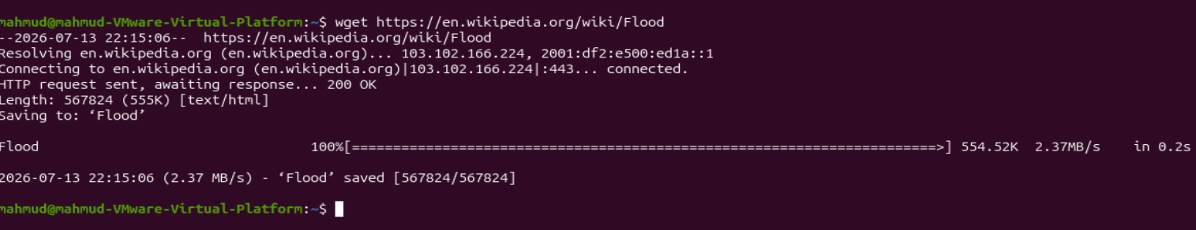
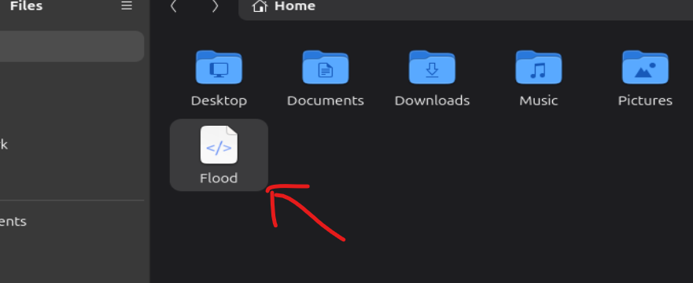

Conclusion:
In this experiment, fundamental Linux commands were practiced to understand file handling, navigate directory, searching text, archiving and remote file downloading. Gaining hands-on experience with these utilities highlights the efficiency of the Command Line Interface (CLI) over traditional graphical interfaces. Ultimately, mastering these core commands provides the essential foundation required to navigate and utilize the Linux operating system effectively in more advanced system-level tasks.

